Lab Report No. 10

Lab Report Name: Implementation of Round Robin Scheduling algorithm .
Objectives:
- What is Round Robin Scheduling algorithm.
- How to implementation

Theory:

- Round Robin is the preemptive process scheduling algorithm.
- Each process is provided a fix time to execute, it is called a quantum.
- Once a process is executed for a given time period, it is preempted and other process executes for a given time period.
- Context switching is used to save states of preempted processes.

Example:
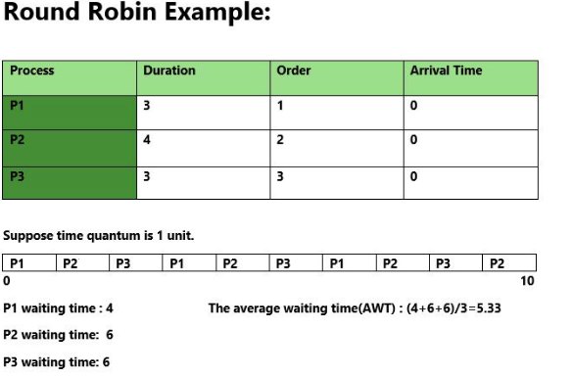

C program to implement Round Robin algorithms:

#include<bits/stdc++.h>
using namespace std;

main()
{
int n;

printf("Enter the number of processes:");
scanf("%d",&n);
int b[n],a[n],w[n],p[n],tq,flag=0,i,k,temp[100],total=0;
for(i=0; i<n; i++)
{
printf("enter burst time of process%d:",i+1);
scanf("%d",&b[i]);
w[i]=0;
p[i]=0;

}

printf("Enter the time quantum:");
scanf("%d",&tq);
i=0;
k=0;

while(1)
{
if(i==n)
i=0;
if(flag==n)
break;

if(b[i]<=tq && b[i]>0)
{
w[i]+=total-p[i];
flag++;

total+=b[i];
b[i]=0;
temp[k]=i;
k++;

}
if(b[i]>tq)
{
w[i]+=total-p[i];
b[i]=b[i]-tq;
total+=tq;
temp[k]=i;
k++;
}
p[i]=total;
i++;
}
printf("\nOrder of execution:\n");
for(i=0; i<k; i++)
{
printf("P%d ",temp[i]+1);
}

int a_w_time=0;
for(i=0; i<n; i++)
{
printf("\nP%d Waiting time %d\n",i+1,w[i]);
a_w_time = a_w_time + w[i];

}
printf("\nAverage Waiting time %.4f\n",((float)a_w_time/(float)n));

}

outputs:
